BDBP106: Linux and Python programming Lab 4
Ankita Bose, PhD
EXERCISES
1.
(1) Create symbolic and hard links to the data file you downloaded.
Softlink created:
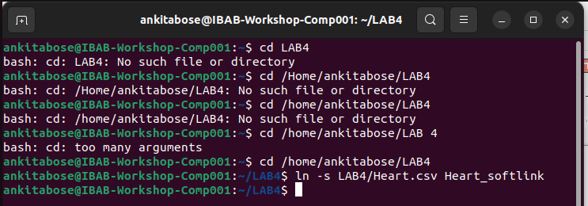
Hardlink created:
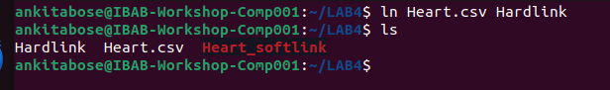
What happens if you use the same name for the links? Print the screenshot of the output message and paste it in your answers.
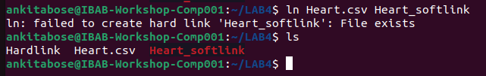
If we input the same name for the links, that the file as the specified name already exists. Hence, the hardlink cannot be created.

Also how do you prove that you have created the links correctly?
Use the appropriate command to prove it.
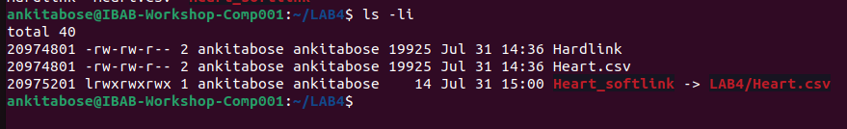

2. 2) What command will you use to determine the filetype of the downloaded data file? Execute this command and take a screenshot of the command and the output to paste it in your work
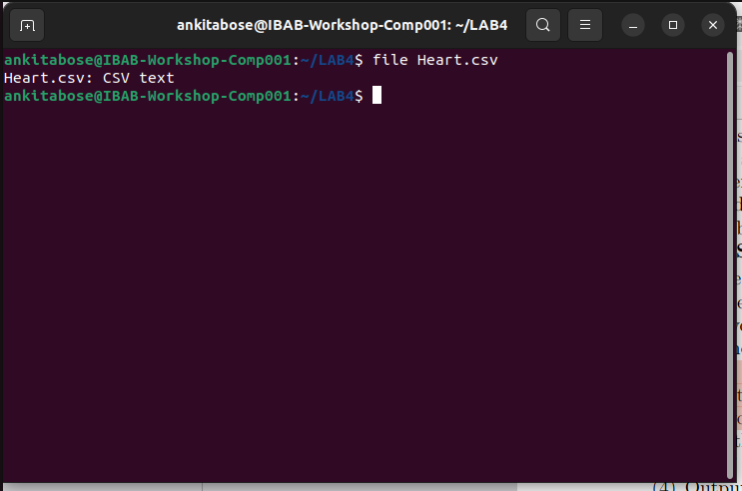
“File” command is used to determine the file type of the downloaded data file.

3. View the contents of the data file using more and less commands. How many pages are there?
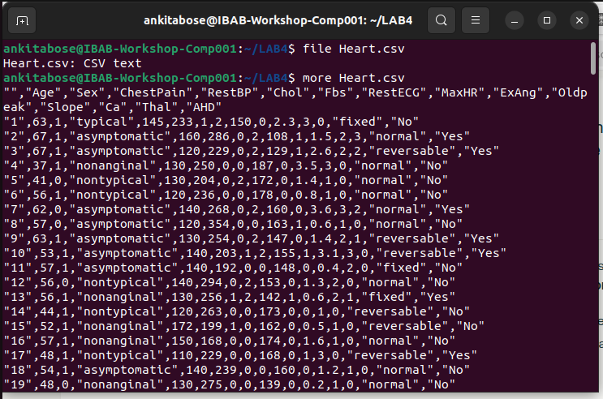
a) “more” command. There were 8 pages.
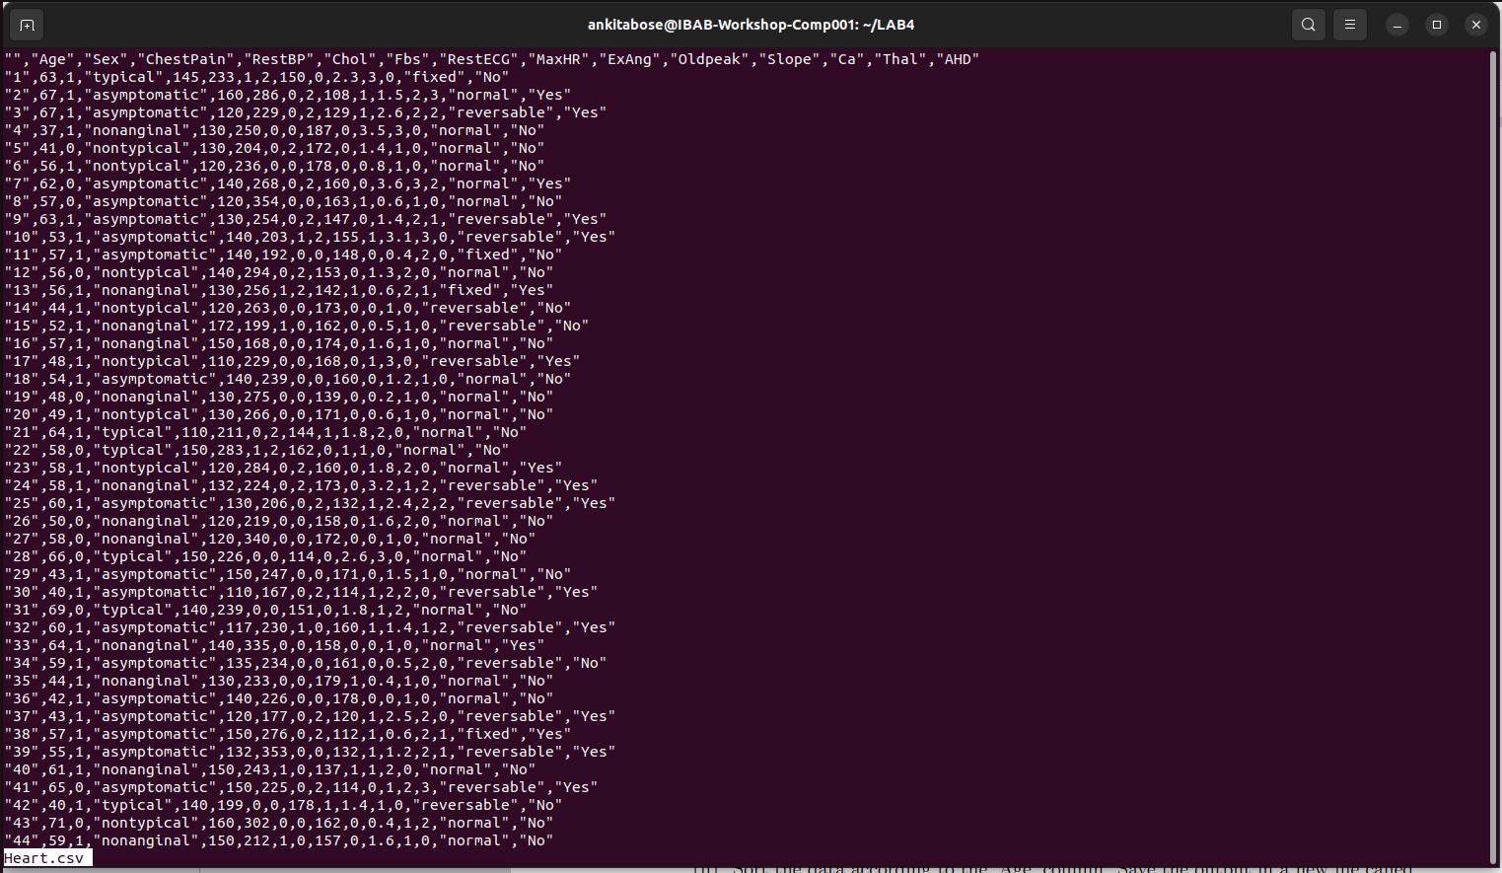
b) “less” command : There are 7 pages.

4. Output the first 35 lines of the data file using the appropriate command. Save the
screenshot in your work.

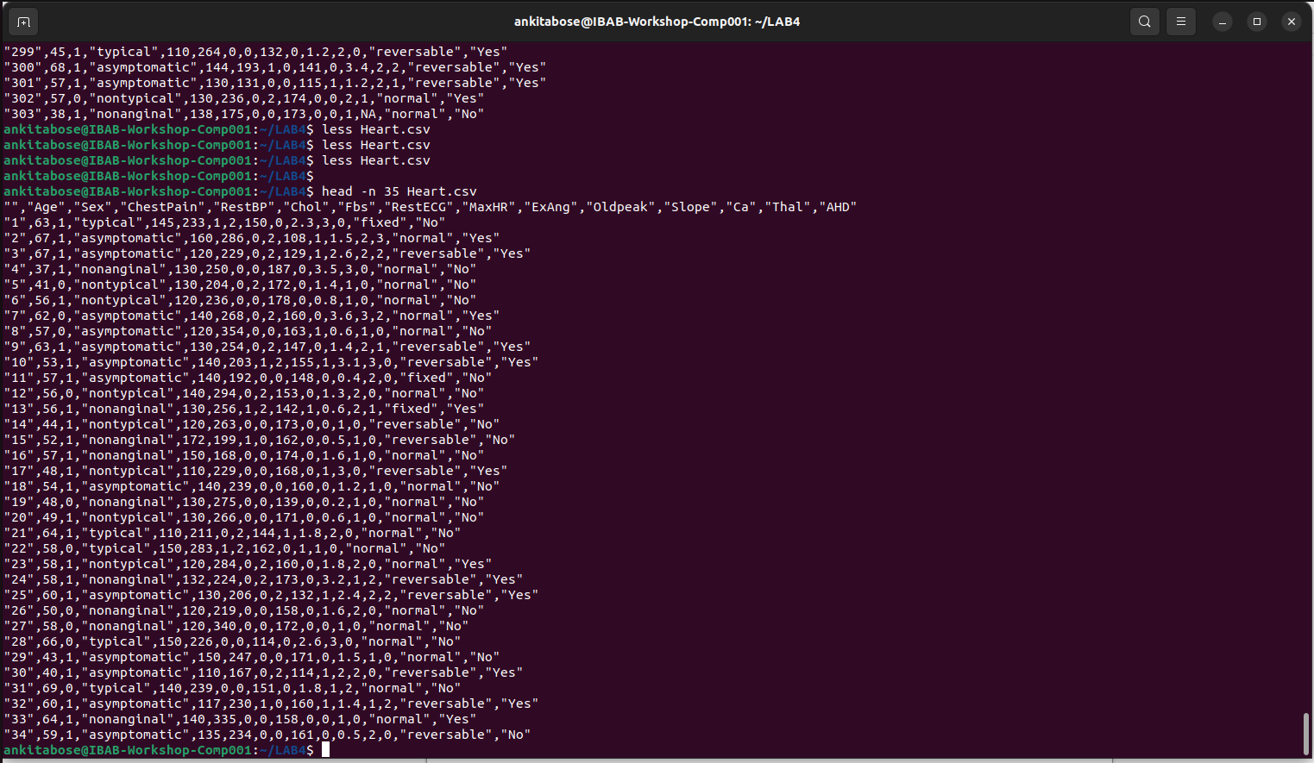

5. Output the last 15 lines of the data file using the appropriate command. Save the
screenshot in your work.
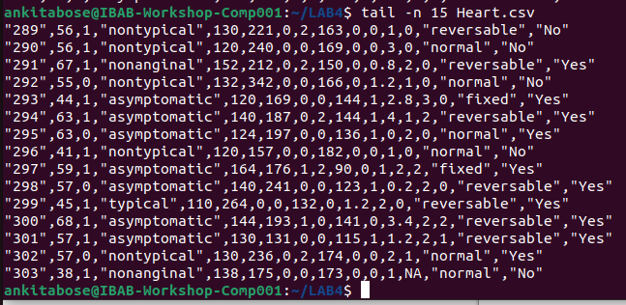
6. Use the history command to list the last few commands, and execute the second last command in your list. Do this using both the process ID and the first letter of the
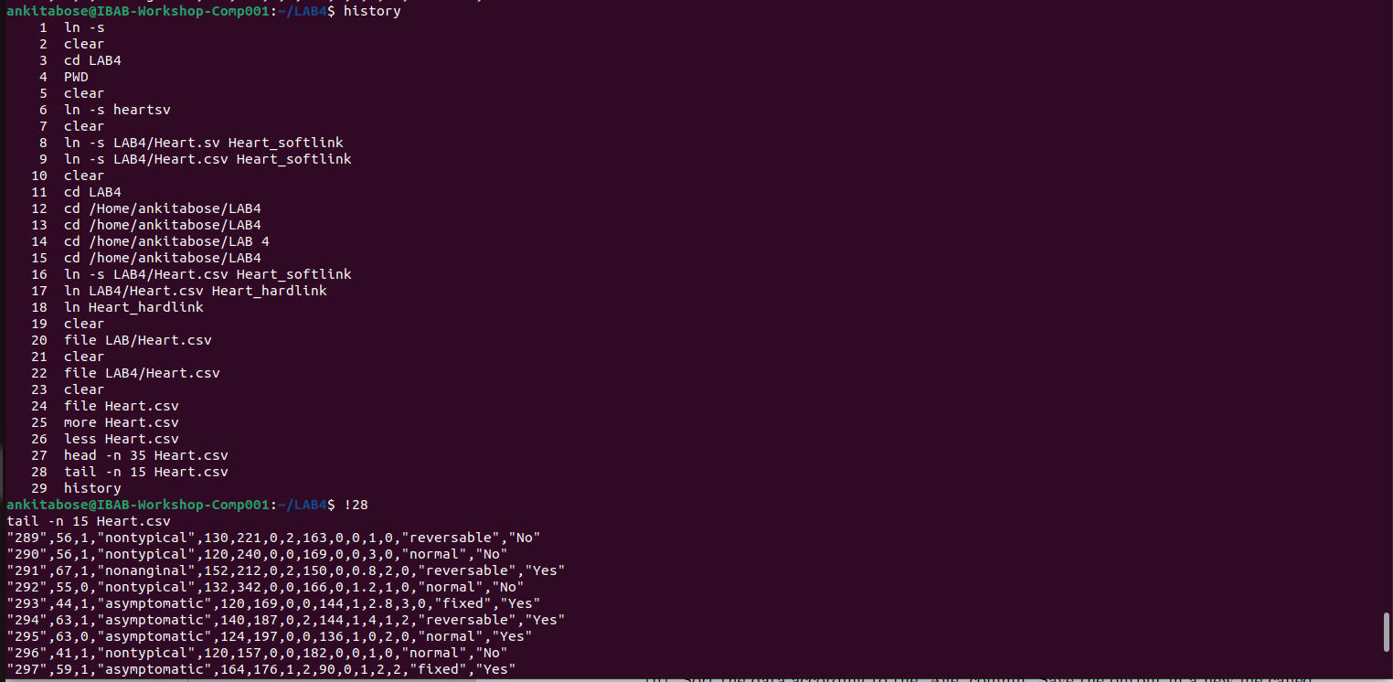
command.

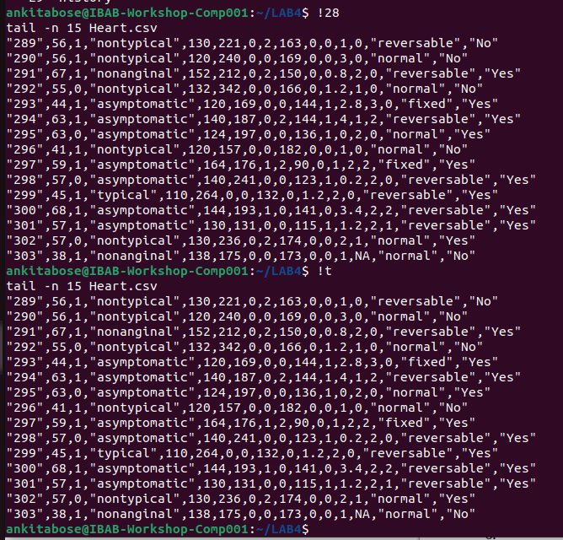

(7) The sort command. For each of the exercises below, find the correct combination of options for the sort command using the man pages. Make sure to show your sequence of steps clearly in your submission work.
(i) Sort the data according to the first column, keeping in mind that the first column
has numbers. Save the output in a new file called col1_sorted.out.
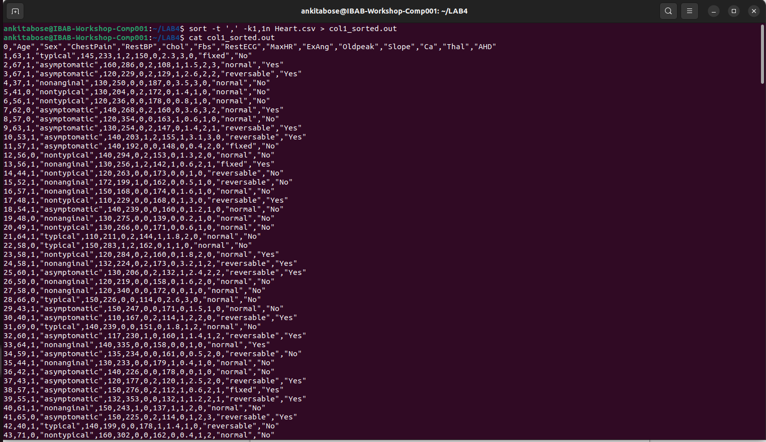

(ii) Sort the data according to the ‘Age’ column. Save the output in a new file called
age_sorted.out.

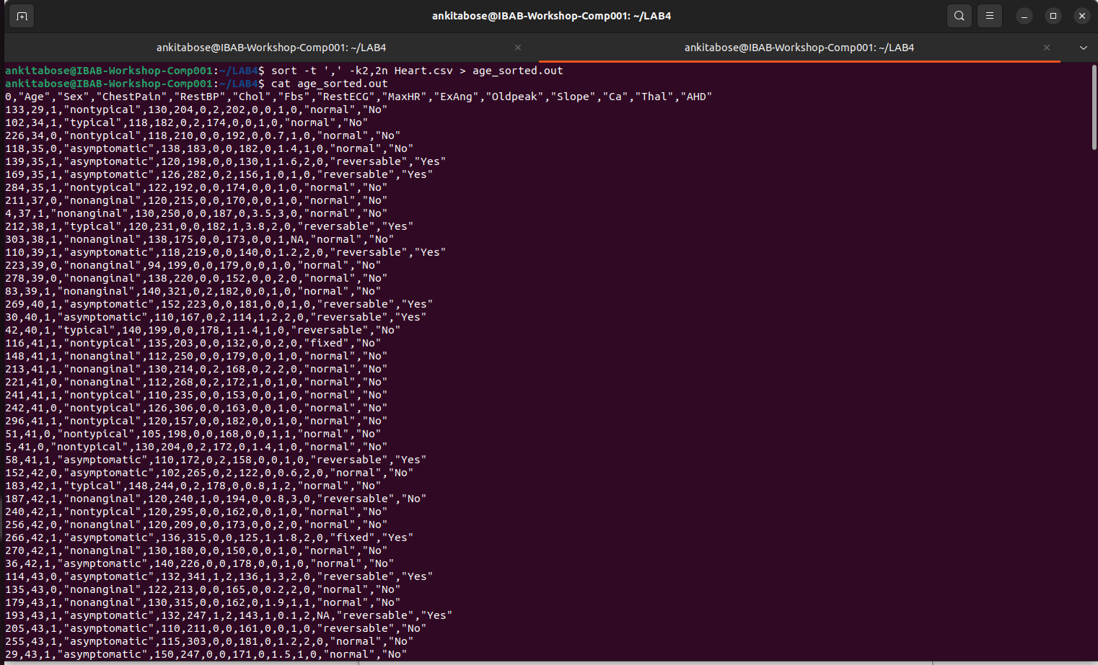
(iii) Sort the data in a reverse manner according to the ’RestBP’ column. Save the
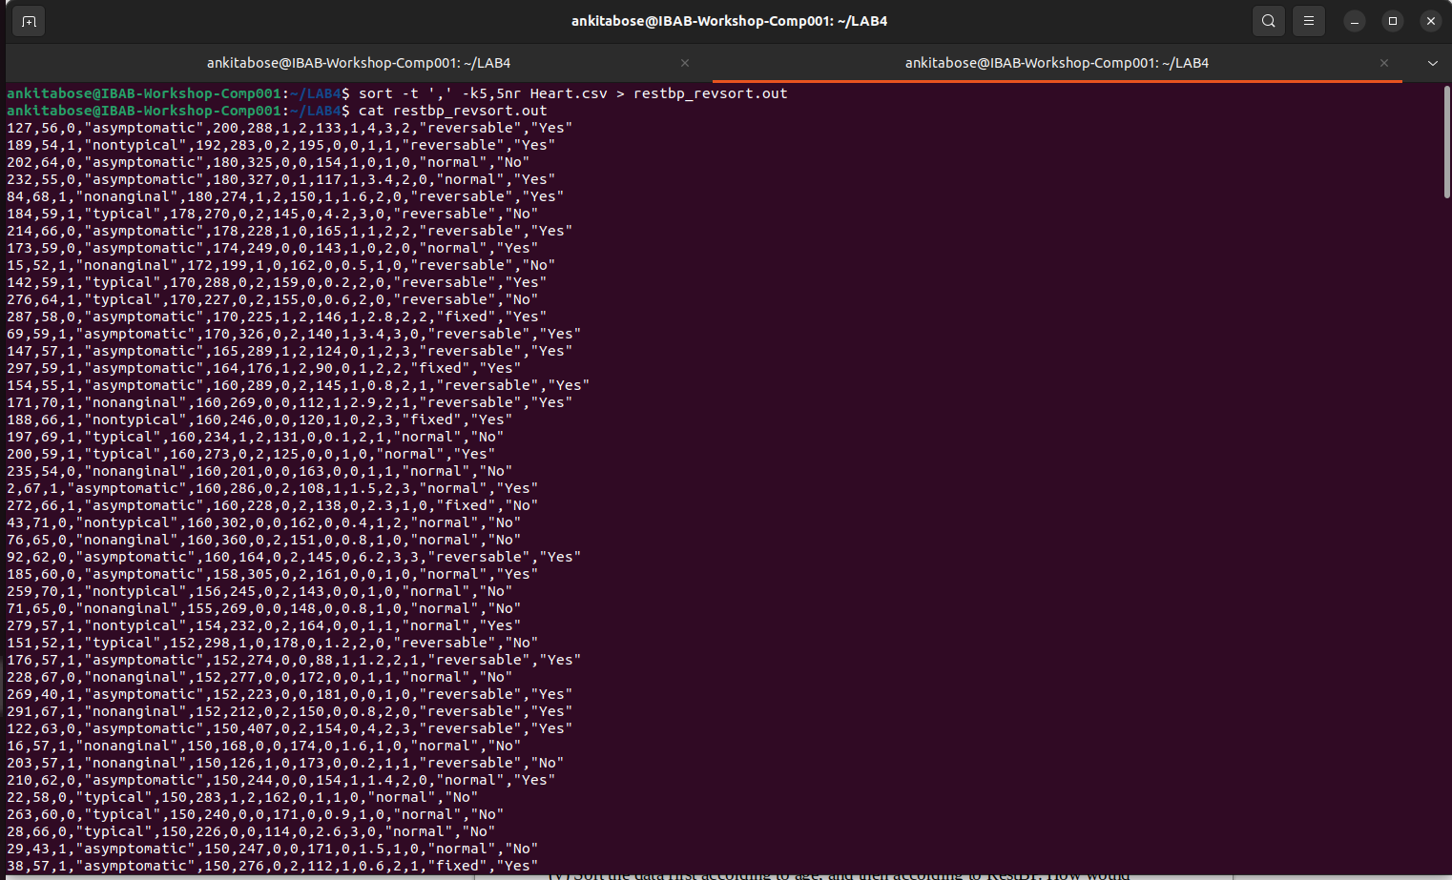
output in a new file called restbp_revsort.out.

(iv) Repeat (ii) and (iii) by giving GNU-style parameters to the sort command. This
is where man pages are extremely useful
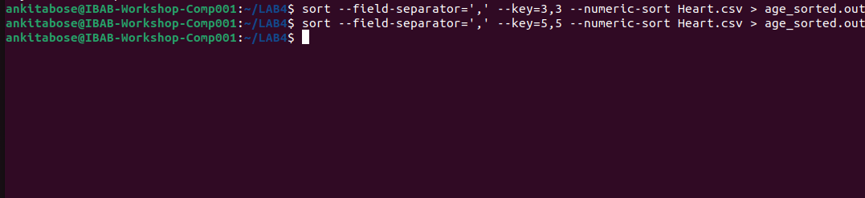
(v) Sort the data first according to age, and then according to RestBP. How would
you do this? Explain the steps clearly.
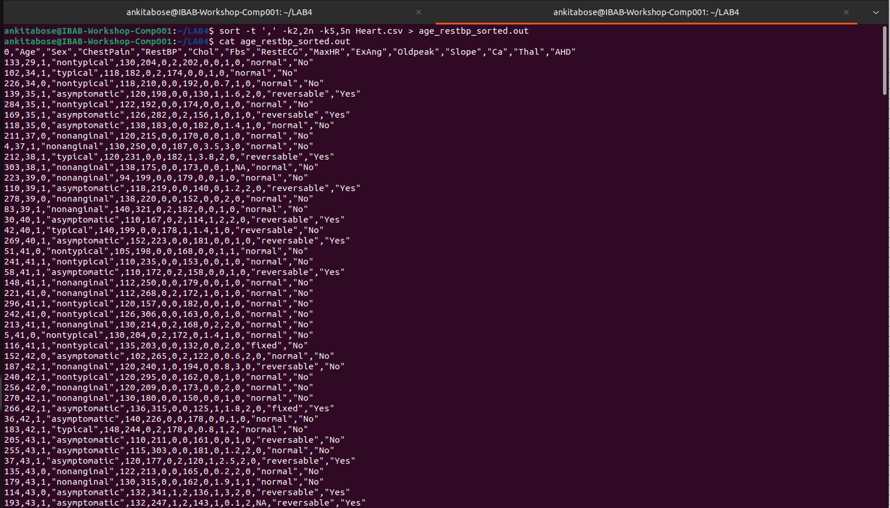
This command sorted the age column first and then sorted the RestBP column. So if there suppose rows which has the same age, it will give those sorted numerical RestBP values.

(vi) Sort the data according to sex, then according to age, then according to ChestPain. Explain the steps clearly
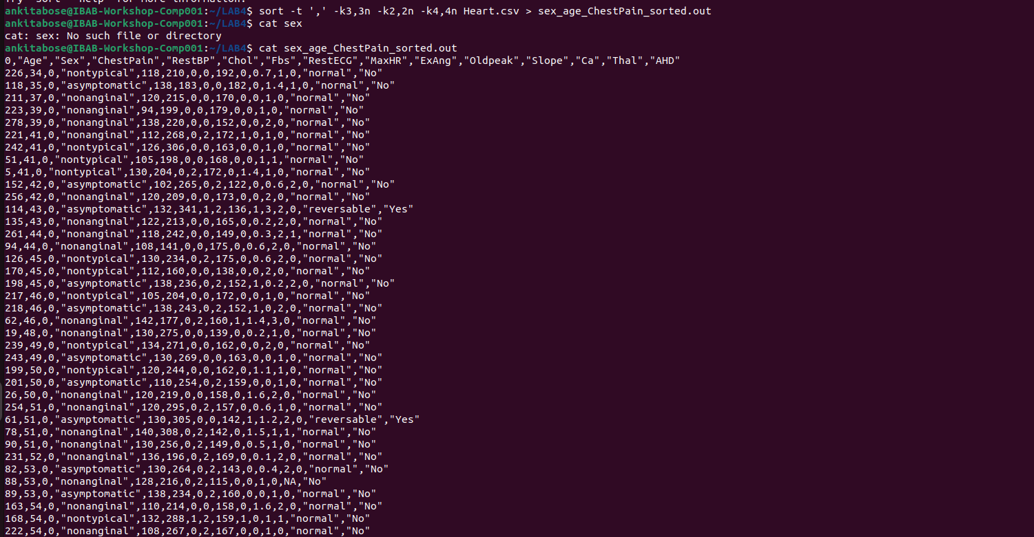

The given command sort the sex numerically, the age numerically and for a certain repeated age given, the chestpain get sorted alphabetically

